
TEACHER KEY

How do Living Things Provide Evidence for Evolution
Homologous Structures

Body parts in different organisms that have the same basic structure are called homologous structures. By comparing homologous structures, biologists can determine how organisms might be related. Homologous structures may not necessarily have the same function, but they are similar in structure (such as bone location and number of bones). The presence of homologous structures suggests that organisms evolved from a common ancestor.
Analogous structures have the same function; but are very different in structure.

- Compare the meaning of the terms “homologous” and “analogous”:
Homologous means similar in structure; analogous means similar in function.

Figure 1: Homologous Structures

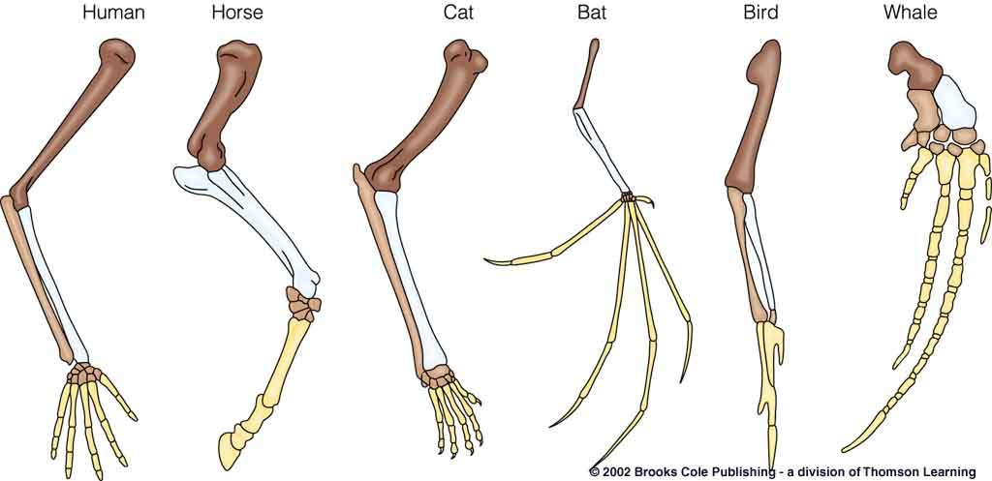

Figure 2: Analogous Structures
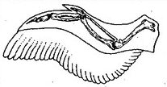
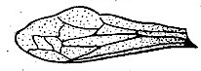

Bird wing
Insect wing

2. Data Table 1: Homologous Structures
Use Figure 1 to complete the table:
Organism | Body Part | Function
Human | Arm | Grasping/climbing
Whale | Fin | Swimming
Cat | Leg | Locomotion (walking, running, climbing)
Bat | Wing | Flying
Bird | Wing | Flying
Alligator | Leg | Swimming/walking

- How are all the body parts in Figure 1 alike? The body parts show very similar structures. The placement of the bones is similar, and the numbers of bones in each area are identical or nearly identical.

- How are they different? The structures are used for different things, such as swimming, flying, walking, so they are not entirely identical in set –up or function.

5. Data table 2: Analogous Structures
Use Figure 2 to complete the table:
Organism | Body Part | Function
Bird | Wing | Flying
Insect | Wing | Flying

Analysis and Conclusions

- Why are the structures in Figure 1 homologous structures? (*note* the definition of homologous structures might be used to help support your answer, but should not serve as the answer itself. Really analyze the structures – be an expert!) The structures in Figure 1 are homologous because they are similar in structure. Among the 6 organisms, the bones seem to branch from 1 upper bone (humerus) to two (radius and ulna) and then there are 5 phalanges present. This suggests that these organisms share a common origin, but have evolved quite differently since then, as they have different functions.

7. Why are the structures in Figure 2 analogous structures? They are analogous because they are different in structure but similar in function.

8. Do the wings of birds and insects suggest an evolutionary relationship? How do you know? There is no suggestion of an evolutionary relationship among bird and insects. They are not similar in any way, except their function. They have no similarities among structure. (Depending on where your students are they may mention convergent evolution).

Vestigial Structures

Vestigial structures are body parts that are found in living organisms, but have no purpose. The question then arises, why are these structures present? Biologists find that these structures may suggest an evolutionary past. For example, snakes have reduced leg bones attached to their pelvic girdle. This suggests that snakes may have evolved from similar animals that indeed had legs and walked.

9. Thinking critically: examine the examples of vestigial structures in the table below. Determine what each vestigial structure may suggest about the organism’s evolutionary past.

Animal | Vestigial Structure | What might this tell us about its evolutionary past?
Ostrich | Wings | Ostrich ancestors once flew using wings
Whale | Pelvic limbs (leg bones) | Whale ancestors once walked on land
Human | Coccyx (tail bone) | Human ancestors once had tails  (perhaps lived in trees)

10. How do vestigial structures provide evidence of an organism’s evolutionary past? Vestigial structures may provide evidence of an organism’s evolution past because it can be assumed that the structures were once used for something, and as the species evolved, the need for these structures diminished (as did the size). We can compare vestigial structures to structures in present day organisms to determine how organisms evolved.

11. How are homologous and vestigial structures alike? How are they different?
Homologous and vestigial structures are alike because they both suggest evidence for evolution. Homologous structures can help determine common ancestors among a group of organisms, whereas vestigial structures can help determine an individual species phylogeny (evolutionary past).

